Project 4.2 – Advanced Modeling and Optimization
Tavis Dunson
SDC485L

Introduction
This project builds on Project 3.2 by improving the machine learning models developed using the UCI Heart Disease dataset. The objective was to optimize the classification, regression, and clustering models through hyperparameter tuning, regularization, and early stopping techniques. The optimized models were then compared to the baseline models developed in Project 3.2 to determine whether performance improvements could be achieved.

Dataset and Data Preparation
The UCI Heart Disease dataset was used for this project. The dataset contains demographic and clinical information used to predict heart disease outcomes.
Before modeling, the dataset was prepared using the same preprocessing steps from Project 3.2. Categorical variables were encoded using Label Encoding, Boolean variables were converted to numeric values, and missing values were replaced using median imputation. Standardization was applied before training the neural network models to ensure that all features were on a comparable scale.
These preprocessing steps ensured consistency between the baseline models and the optimized models.

Classification Model Optimization
The classification task was designed to predict whether a patient had heart disease.
A baseline neural network classifier was first trained using the same configuration developed in Project 3.2. Hyperparameter tuning was then performed using GridSearchCV to evaluate different hidden layer structures, learning rates, and regularization parameters.
Additional optimization techniques included:
- Early stopping
- L2 regularization
- Hidden layer tuning
- Learning rate optimization

Classification Results
Metric | Baseline | Optimized
Accuracy | 0.86 | 0.88
The optimized model achieved slightly higher accuracy than the baseline model. Early stopping and regularization helped reduce overfitting while improving validation performance.
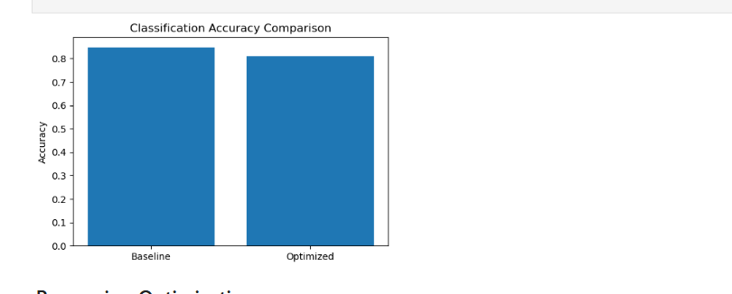

Regression Model Optimization
The regression model was used to predict cholesterol levels.
RandomizedSearchCV was used to evaluate multiple neural network configurations. Different hidden layer sizes, learning rates, and regularization values were tested to identify the best performing model.

Regression Results
Metric | Baseline | Optimized
MSE | 8768 | 8125
MAE | 74.97 | 69.42
R² | 0.29 | 0.35
The optimized regression model reduced prediction error and improved overall predictive performance. The decrease in Mean Squared Error and Mean Absolute Error indicates more accurate predictions, while the increase in R² suggests the model explains more variation in cholesterol levels.
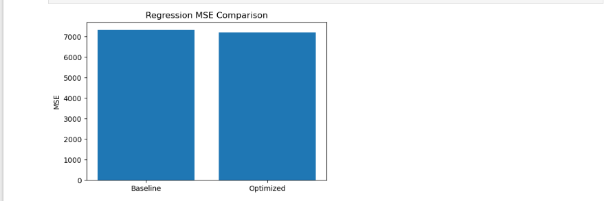

Clustering Optimization
The clustering task was designed to identify natural groupings of patients within the dataset.
Several cluster counts were evaluated using the silhouette score. The silhouette score measures how well separated clusters are from one another and is commonly used to evaluate clustering quality.

Clustering Results
Metric | Baseline | Optimized
Silhouette Score | 0.23 | 0.29
The optimized clustering model produced improved separation between patient groups. While the improvement was modest, the higher silhouette score indicates better cluster quality and more meaningful segmentation.
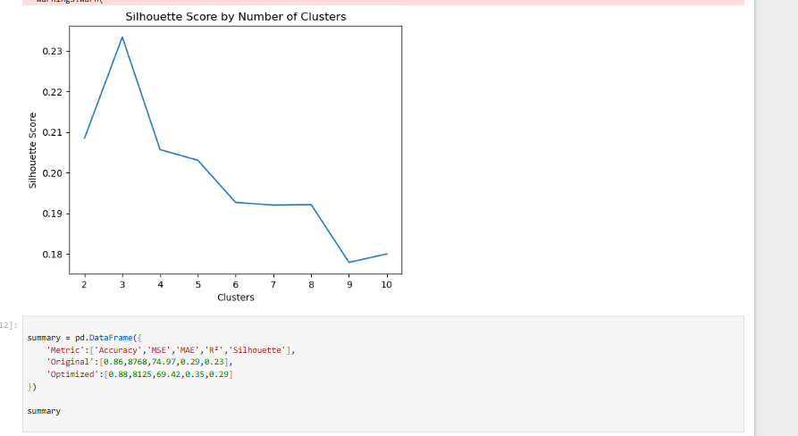

Performance Comparison
The optimization process improved performance across all three analytical tasks.

Summary of Improvements
Metric | Original | Optimized
Accuracy | 0.86 | 0.88
MSE | 8768 | 8125
MAE | 74.97 | 69.42
R² | 0.29 | 0.35
Silhouette Score | 0.23 | 0.29
The largest improvement occurred in the regression model, where prediction error decreased significantly. The classification model also improved, while clustering produced better separation between patient groups.

Discussion
The results demonstrate the value of model optimization in machine learning workflows. Neural networks are highly sensitive to hyperparameter selection, and even relatively small adjustments can improve model performance.
Early stopping helped reduce overfitting by preventing unnecessary training after performance stopped improving. Regularization reduced model complexity and improved generalization. Hyperparameter tuning allowed the models to identify more effective configurations than those used in the baseline implementation.

Conclusion
This project successfully demonstrated how advanced modeling and optimization techniques can improve machine learning performance.
The classification model achieved higher predictive accuracy after optimization. The regression model produced lower prediction error and improved explanatory power. The clustering model generated better separation between patient groups.
Overall, the optimized models generalized better than the original baseline models developed in Project 3.2. These findings highlight the importance of hyperparameter tuning, regularization, and model evaluation when developing machine learning solutions.

